**DATA STRUCTURE LAB**



**LAB REPORT: 01**

|  |  |
| --- | --- |
| **Name** | M. ZAIN PARACHA |
| **Registration Number** | 200901076 |
| **Batch & Section** | CS (01)-A |
| **Assignment** | DATA STRUCTURE LAB |
| **Submitted to** | SIR NADEEM |
| **Date** | 22ND OCT, 2021 |

**TASK: 01**

Q. Write a program to let the user enter a string of his own choice. Check whether the given string is a palindrome or not.

Sample Input: LEVEL

Output: Given string is Palindrome

Sample Input: LEVELL

Output: Given string is not Palindrome

**ANSWER:**

|  |
| --- |
| st=input("enter a string:")  i=-1  j=0  for a in st:    if a !=st[i]:      i=i-1      j=1      break    i=i-1  if j==1:    print("Given string is not palindrome")  else:      print("Given string is a palindrome") |

**OUTPUT:**

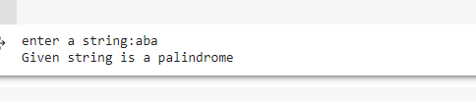

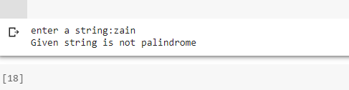

**TASK: 02**

Q. Write a program to check the balanced parenthesis in the expression or not using stack:

**ANSWER:**

|  |
| --- |
| def check(st):      brackets = ['()', '{}', '[]']      while any(x in st for x in brackets):          for y in brackets:              st = st.replace(y, '')      return not st  string = input("Enter any brackets:")  print(string, "-", "Balanced"        if check(string) else "Unbalanced") |

**OUTPUT:**

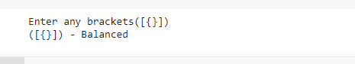

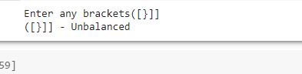

**END**